Name: Kuimu Ren

USC ID Number:1473482531

USC Email:kuimuren@usc.edu

Submission Date: 03/10/2024

**Problem1**

**Geometric Image Modification**

**Abstract and Motivation:**

Spatial warping is a type of image processing method that involves transforming the spatial coordinates of an image to achieve adjustments in its shape and structure. This technique finds applications in image reconstruction, special effects processing, object deformation, and various other domains.

**Approach and Procedures:**

First, divide the square picture into four triangular parts, and then six pairs of points are selected on the triangle, which are used as matching points before and after the transformation.

Second, with six pairs of points, we can find a 2x6 transition matrix.

$$\left[\begin{matrix}u \\ v\end{matrix}\right]= \left[\begin{matrix}a_{0} & a_{1} & a_{2 } \\ b_{0} & b_{1} & b_{2}\end{matrix} \begin{matrix}a_{3} & a_{4} & a_{5} \\ b_{3} & b_{4} & b_{5}\end{matrix}\right]\left[\begin{aligned}1 \\ x \\ y \\ x^{2} \\ xy \\ y^{2}\end{aligned}\right]$$

Third, Then we can use forward address mapping or inverse address mapping by transition matrix to find corresponding pixel in original image.

Fourth, If inverse address mapping is used, after the corresponding pixel position is obtained by using transform matrix, we also need to use bilinear interpolation to transform the pixel.

$$color\left(p,q\right)= xycolor\left(m+1,n+1\right)+x\left(1-y\right)color\left(m,n+1\right)+\left(1-x\right)ycolor\left(m+1,n\right)+(1-x)(1-y)color(m,n)$$

Last, output the image.

**Experimental Results:**

Shown below are the results of Problem 1:

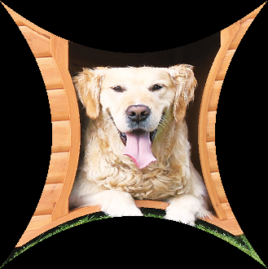

Figure1: dog image by spatial warping technique

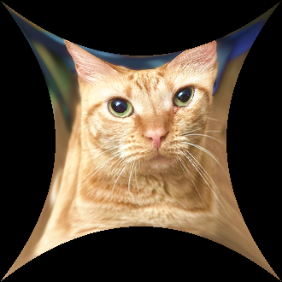

Figure2: cat image by spatial warping technique

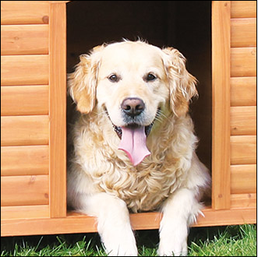 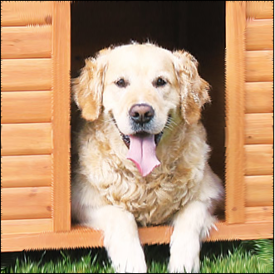

1. (b)

Figure3: (a)original dog image and (b)dog image by reverse spatial warping

 

1. (b)

Figure4: (a)original cat image and (b)cat image by reverse spatial warping

**Homework Answer and Discussion:**

1. My approach is described in approach and procedures, and result image is showed in Figure1 and Figure2.
2. Original image and recovering image is showed in Figure3 and Figure4.
3. We can see that there are some black pixels around the edges of the restored pattern, and there are many places in the image where we can find distortions.

Reason: First, this is because when using warping, the transformed image is smaller than the original one, resulting in the loss of pixels that have to be replaced by surrounding pixels when the image is restored. Second, when using reverse spatial, we use bilinear interpolation, which will change the original pixel values, so it will cause slight differences.

**Problem2**

**Homographic Transformation and Image Stitching**

**Abstract and Motivation:**

Homographic transformation is a perspective transformation commonly used in computer vision to map points from one plane to another. This transformation is widely employed for tasks such as image alignment, object tracking, and camera calibration. The homography matrix, a 3x3 matrix, describes the mapping relationship between two-dimensional planes.

**Approach and Procedures:**

First, we need to find control points, we can choose control points from the images using methods like SIFT (Scale-Invariant Feature Transform) or SURF (Speeded-Up Robust Features) for detecting control points.

Second, we need to find the relatively accurate pairwise control points from all the control points.

Third, calculate and apply the homographic transformation using the control points to obtain the homography matrix H, describing the mapping relationship between the images.

Fourth, using the computed homography matrix H, the left and right images are transformed so that they align with the middle image.

Fifth, create a new image large enough and stitch the three images together.

**Experimental Results:**

Shown below are the results of Problem 2(a):

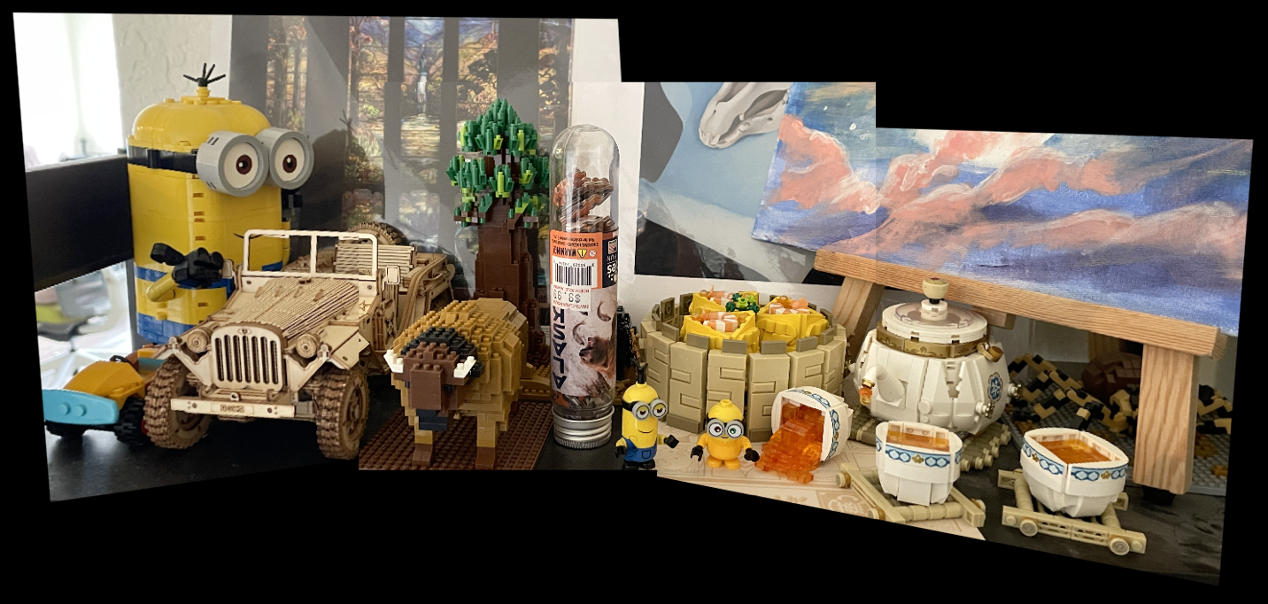

Figure1: The result image of homographic transformation and stitching techniques

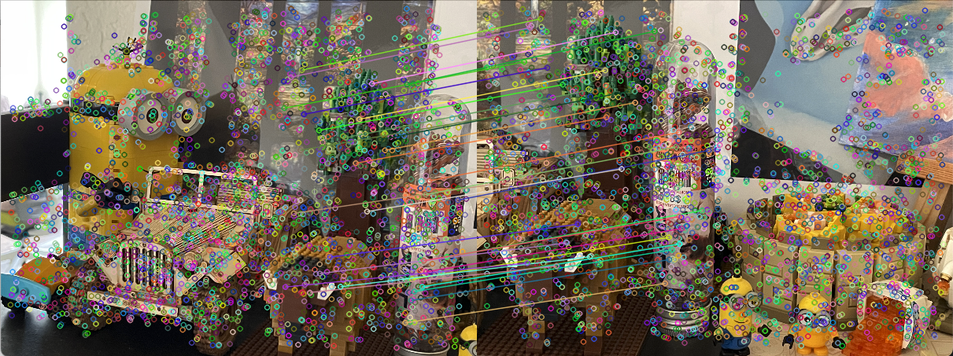

Figure2: The matching control points between left and center pair

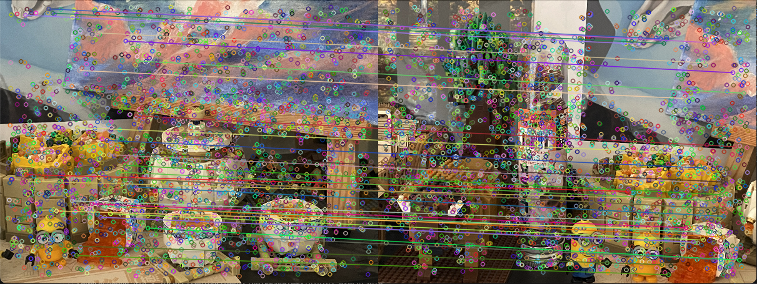

Figure3: The matching control points between right and center pair

**Homework Answer and Discussion:**

1. In my experiments, I used 32 pairs of control points between left and center and right and center, it is shown in figure2 and figure3.
2. I applied SURF to both images to perform feature detection to identify keypoints or interest points in the image that are invariant to scale, rotation, and illumination changes.

Then I used the k-nearest neighbors matching method for all control points. For each feature point to be matched, the nearest distance of all control points is calculated. By comparing the distances of the nearest neighbors in the two graphs, those matching pairs with large distance differences are kept. A smaller distance difference usually means that the two points are more similar in the feature space, while a larger distance difference may be a more reliable match.

**Problem3**

**Abstract and Motivation:**

Shrinking, thinning, and skeletonizing are common operations in morphological image processing designed to manipulate the structures within an image, simplify shapes, or extract crucial features.

1. **Basic morphological process implementation**

**Approach and Procedures:**

First, we need to binarize the image to form a grayscale image with only 0 and 255. If the pixel value is greater than or equal to 127, it is changed to 255; otherwise, it is changed to 0.

Second, we fill the boundary with zeros.

Third, we need to create a new M of the same size to store the intermediate matrix, then we need to check all the 3x3 intervals in the image and change the M in the corresponding position to 1 if it belongs to one of the conditional mark patterns of the corresponding type, it means hit.

Fourth, for all the positions where M is 1, check whether the 3x3 part in the original image at the corresponding position is equal to one of the unconditional mark patterns. If yes, the original image will be kept unchanged; if not, this position in the original image will be changed to 0.

Fifth, repeat third and fourth step until no more pixel is changed to 0.

**Experimental Results:**

Shown below are the results of Problem 3(a):

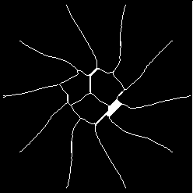 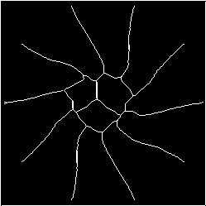

1. (b)

Figure1: (a)intermediate(20th) shrinking flower image and (b)final shrinking flower image

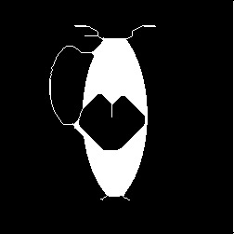 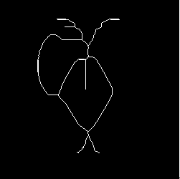

1. (b)

Figure2: (a)intermediate(20th) shrinking jar image and (b)final shrinking jar image

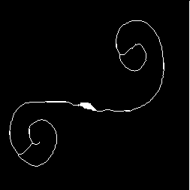 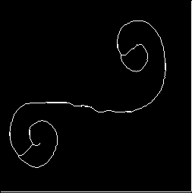

1. (b)

Figure3: (a)intermediate(20th) shrinking spring image and (b)final shrinking spring image

**Homework Answer and Discussion:**

Figure1,2,3 shows the results of the twentieth and final changes of the three pictures respectively. We can find that the lines of the pictures will gradually become thinner, and the regions formed by the original pictures will still have the same number of regions even after the thinning operation.

1. **Shape detection and counting**

**Approach and Procedures:**

1. First, we need to binarize the image and fill the boundary with zeros.

Second, we need to inverse the black and white pixel in image, 255 change to 0, 0 change to 255, the result shows in figure1.

Third, we need to use method in (a) to shrink the image, the single white pixel is the number of black circular holes within white objects in the original image, the result shows in fugure2.

Last, we iterate over the image with a 3x3 matrix to see how many single white pixels there are.

1. First, We need to process the processed image in (1), and eliminate the single white pixel found in the image (converting to 0).

Second, we need to inverse the black and white pixel in image, 255 change to 0, 0 change to 255, the result shows in figure3.

Third, we need to use method in (a) to shrink the image, the single white pixel is the number of white objects in the original image, the result shows in fugure4.

Last, we iterate over the image with a 3x3 matrix to see how many single white pixels there are.

1. (4)First, we need to find all the black circular holes within white objects, we can use the method in (1).

Second, we can see that the shrinking points in (1) must be in the original black circular holes, so we can record the positions of these points, and then use DFS recursively to find all the adjacent black points in these positions in the original image, and turn them all into white points. This way we will be able to fill all the black circular holes with white. The result shows in figure5.

Third, we use the thinning method in (1), and we will find that all circles will become a point and all rectangles will become a line in the end. The result shows in figure6.

Fourth, for points we can iterate over the image with a 3x3 matrix to see how many single white pixels there are and then eliminate these points (convert to 0).

Last, for rectangles, we can use a new space of the same size as the original image to keep track of whether it has been visited, and then traverse the whole image and use DFS to find out how many white connected regions there are, and this number is the number of rectangles.

**Experimental Results:**

Shown below are the results of Problem 3(b):

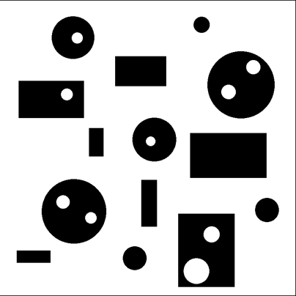

Figure1: inverse black and white

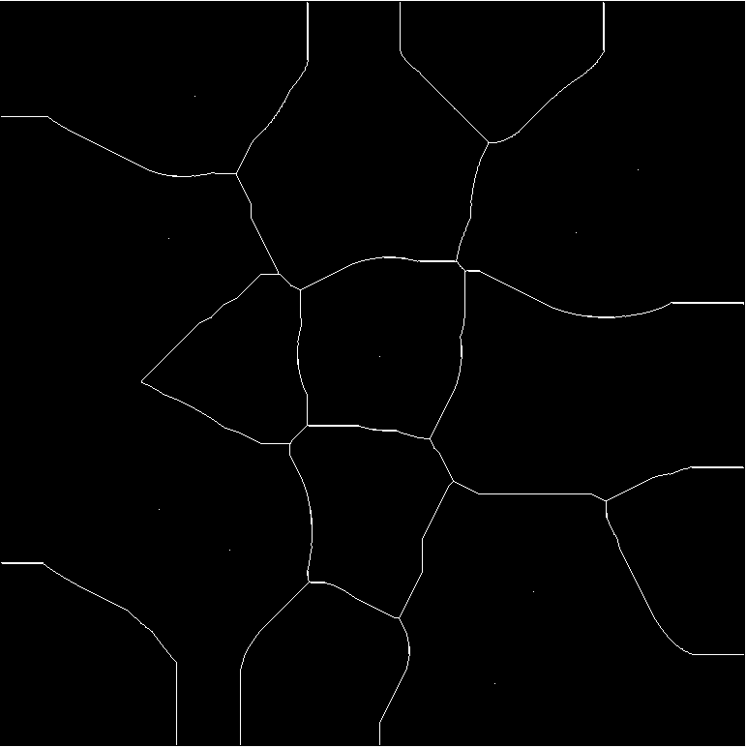

Figure2: shrinking image

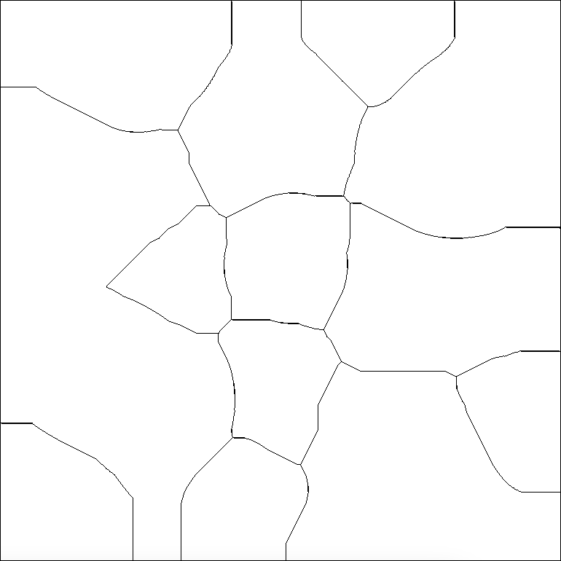

Figure3: inverse image



Figure4: shrinking image



Figure5: The image after removing the black circle



Figure6: The image after thinning

**Homework Answer and Discussion:**

1. There are 9 holes (black circular holes within white objects) in the image, the algorithm and analysis can be found in the Approach and Procedures part (1), and result image shows in Figure1,2.
2. There are 14 white objects in the image, the algorithm and analysis can be found in the Approach and Procedures part (2), and result image shows in Figure3,4.
3. There are 7 white rectangle objects (with or without holes) in the image, the algorithm and analysis can be found in the Approach and Procedures part (3), and result image shows in Figure5,6.
4. There are 7 white circle objects (with or without holes) in the image, the algorithm and analysis can be found in the Approach and Procedures part (4), and result image shows in Figure5,6.
5. **Object Segmentation and Analysis**

**Approach and Procedures:**

First, we need to convert the image from color image to binary image, to black and white image, where we need to set a suitable threshold, then above the threshold conversion to 0, below the threshold conversion to 255, we can get the mask of the image. The result shows in figure1.

Second, we can use the same method in a(3) to eliminate holes in beans. The result shows in figure2.

Third, we can use the method in a(1) to shrink the bean into a point and then count the number of beans.

Fourth, back to second step, we can traverse the whole image and use DFS to find out all white regions and record the number of white pixels in the region. Then the type and the number of corresponding white pixels are recorded in the map.

Last, sort the data in the map from smallest to largest according to the number of white pixels. The result shows in Figure3.

**Experimental Results:**

Shown below are the results of Problem 3(a):



Figure1: beans mask



Figure2: new beans mask

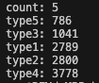

Figure3: beans sort

**Homework Answer and Discussion:**

1. The total number of beans are 5, the algorithm and analysis can be found in the Approach and Procedures part, and result image shows in Figure1,2.
2. The sort of bean’s size shows in Figure3, the algorithm and analysis can be found in the Approach and Procedures part.